
CWorks-CXF-V1
SOFTWARE DESIGN DESCRIPTION
Revision History
Version | Author | Date | Remarks
1.0 | Suresh S | 21-11-2017 | Created

Software Design Document (High Level) for CWorks CXF Conversion System.

Table of Contents
1 Introduction 3
1.1 Purpose 3
1.2 Scope 3
1.3 Product / System Overview 3
1.4 Definitions, Acronyms & Abbreviations 4
1.5 Design and Implementation Constraints 5
1.6 Assumptions and Dependencies 5
1.7 References 5
2 High Level Design (System Architecture) 6
3 Low Level Design (Detail Design) 7
3.1 Analysis Model 7
3.2 Design Model 9
4 Database Design 10
4.1 ER Model 11
4.2 Database Object Definitions 11
5 Appendices 11

Introduction

Purpose

The purpose of this document is to represent the software components, interfaces, and data necessary for the implementation phase based on software requirements. The SDD shows how the software system will be structured to satisfy the requirements. It is the primary reference for code development and, therefore, it contains all the information required by a developer to start coding. This SDD document is performed in two stages. The first is a preliminary design in which the overall system architecture and data architecture is defined. In the second stage, i.e. the detailed design stage, more detailed data structures are defined and algorithms are developed for the defined architecture.

Scope

This system will be a CAD CXF Conversion System for CWorks in Japan. CWorks run their own desktop application product which processes the AutoCAD drawing files generated from AutoCAD and customize them according to their requirement. The present desktop application does not support latest version of AutoCAD files. In order to overcome this issue, CWorks requires a system which converts these drawing files (DWG or DXF) to an intermediate format (CXF). This format will be a text format which includes all information regarding the objects in the drawing file. The system should support the reverse conversion of CXF file to drawing file.
More specifically, this system is designed to convert the drawing files to a desired text format and vice versa. The output of the conversion process will be used by CWorks CAD Processing system to improve the customization of AutoCAD files without any version conflict.

Product / System Overview

Currently the C-Works CAD system has issues with processing the latest versions of AutoCAD drawing files. As a solution for this issue, the proposed system will help to convert the standard AutoCAD file format to a neutral data exchange format (CXF format). The custom format should contain all information about the objects in the AutoCAD drawing files in a simple text format. CXF file contains only the required objects and properties for further processing of the drawing file through CWorks CAD system. A TXF file with all objects and properties of the drawing file also will be generated along with the CXF file.
This neutral format should be able to convert back to drawing files of different AutoCAD versions. For successful reverse conversion TXF file objects and properties will be used along with the CXF file generated from the CWorks CAD system. Our proposed project, marked in the red box, interacts with the AutoCAD System as given below.
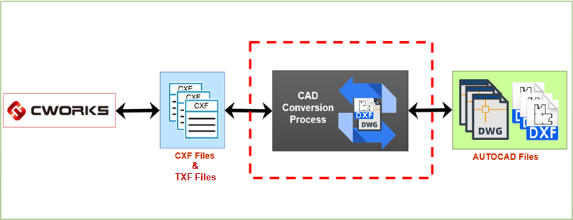
Process Flow –Description
- CAD Conversion Process will convert the drawing files to CXF format and vice versa.
- Input path and Output path will be specified as parameters.
- System will support following conversions:
  - DWG to CXF
  - DXF to CXF
  - CXF to DWG
  - CXF to DXF
Optional parameters like Version, Paper size, Font etc required for CXF to drawing file conversions.

Definitions, Acronyms & Abbreviations

Term | Definition
DWG | DWG (“drawing”) is a binary file format used for storing 2D and 3D design/drafting data. It is the native format for several CAD packages including AutoCAD, IntelliCAD,Caddie and by many other CAD applications.
DXF | AutoCAD DXF (Drawing Interchange Format or Drawing Exchange Format) is a CAD data file format developed by Autodesk for enabling data interoperability between AutoCAD and other programs.
TXF | Text Exchange Format includes all properties of objects in the drawing file to generate output in text format.
CXF | CWorks Exchange Format includes only the required properties of objects in the drawing file to process in CWorks CAD System.
User | Person who inputs and process the drawing file.
ODA | Open Design Alliance
Teigha | Teigha is a professional solution for engineering applications — from simple utilities to comprehensive CAD editors.
SDK | Software Development Kit

Design and Implementation Constraints

- The Teigha Extension (TX) SDK is a free SDK based on C++ and .NET. It allows access and manipulates data loaded from a DWG/DXF file. The project needs a considerable amount of research and development in this regard.
- Latest versions of AutoCAD drawing files are required to process using the proposed system.
- Reverse conversion of CXF file format to specific versions of drawing files is a major constraint.

Assumptions and Dependencies

- Current issues are related to processing the latest versions of AutoCAD files in CWorks CAD system because of the incompatibility of the DXF format for 3D objects.
- Proposed system need not support versions of AutoCAD earlier than AutoCAD 2000.
- Teigha libraries are bug free as it is being maintained by a huge group of professional programmers and also it is a paid service.
- CWorks CAD output will be the original drawing with added scaffolding structure.

References

Documents used for the reference of this SDD document are:

- SDK’s for processing the CAD files are available in the following website:
- https://www.opendesign.com/

High Level Design (System Architecture)

DWG/DXF to CXF Conversion
One process will accept the drawing files (DWG / DXF) as input and converts to CXF and TXF files. CXF Conversion system will read the objects in drawing file using DWG Reader and writes the objects properties to CXF & TXF files using CXF Writer using Teigha libraries. Activity Logger will keep track of the process logs and error logs. System supports single file processing and conversion.
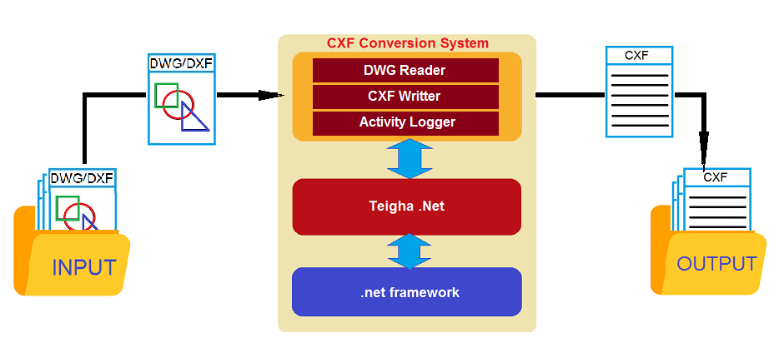

CXF to DWG/DXF Conversion
Another process will accept the CXF file as input and converts to drawing files (DWG / DXF) files with reference of TXF files. CXF Conversion system will read the objects in CXF & TXF files using CXF Reader and creates the drawing file using DWG Writer using Teigha libraries. Activity Logger will keep track of the process logs and error logs.
For processing CXF files the system requires to specify the version, paper size, font etc. for proper conversion.
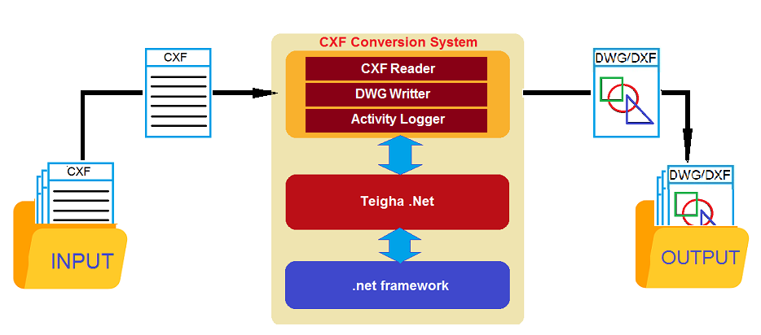

Low Level Design (Detail Design)

Analysis Model

Sequence Diagram – Process
# | Analysis Objects | Responsibilities
1 | Main Program | Accept input parameters like InputFilePath, OutputFilePath, version, paper size, font etc.
2 | Main Controller | Validate parameters & Run the process
3 | DWGReader (DWG/DXF to CXF conversion) | Open drawing file (DWG/DXF) in read mode and read the entities.
4 | CXFWriter (DWG/DXF to CXF conversion) | Open CXF & TXF files in write mode and write the entities properties.
5 | CXFReader (CXF to DWG/DXF conversion) | Open CXF & TXF files in read mode and read the entities properties.
6 | DWGWriter (CXF to DWG conversion) | Open DWG file in write mode and write entities to file.
7 | DXFWriter (CXF to DXF conversion) | Open DXF file in write mode and write entities to file.
8 | ActivityLog | Write process and error logs during the process execution.
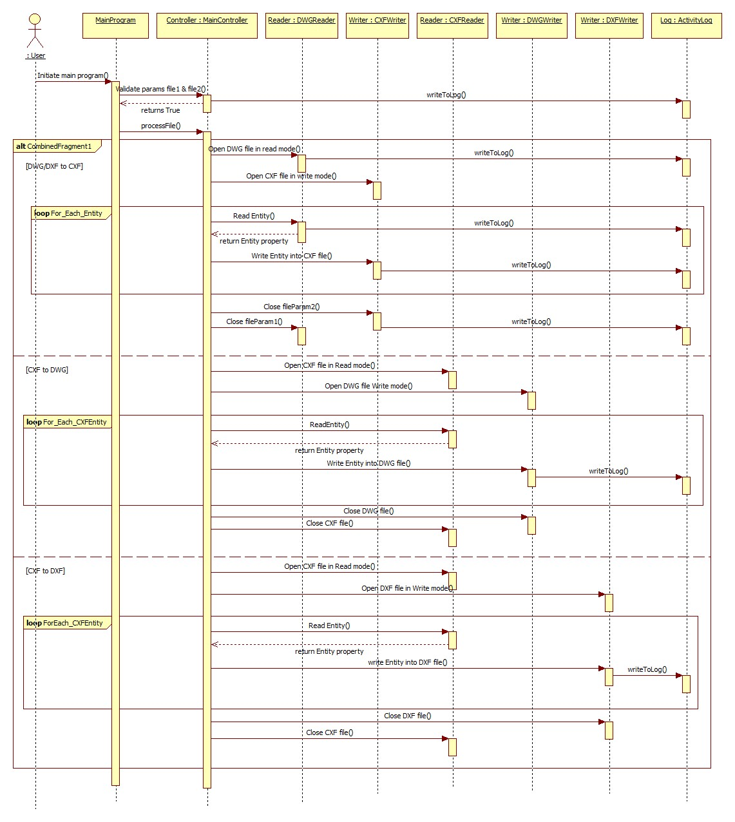

Design Model

Class Diagram
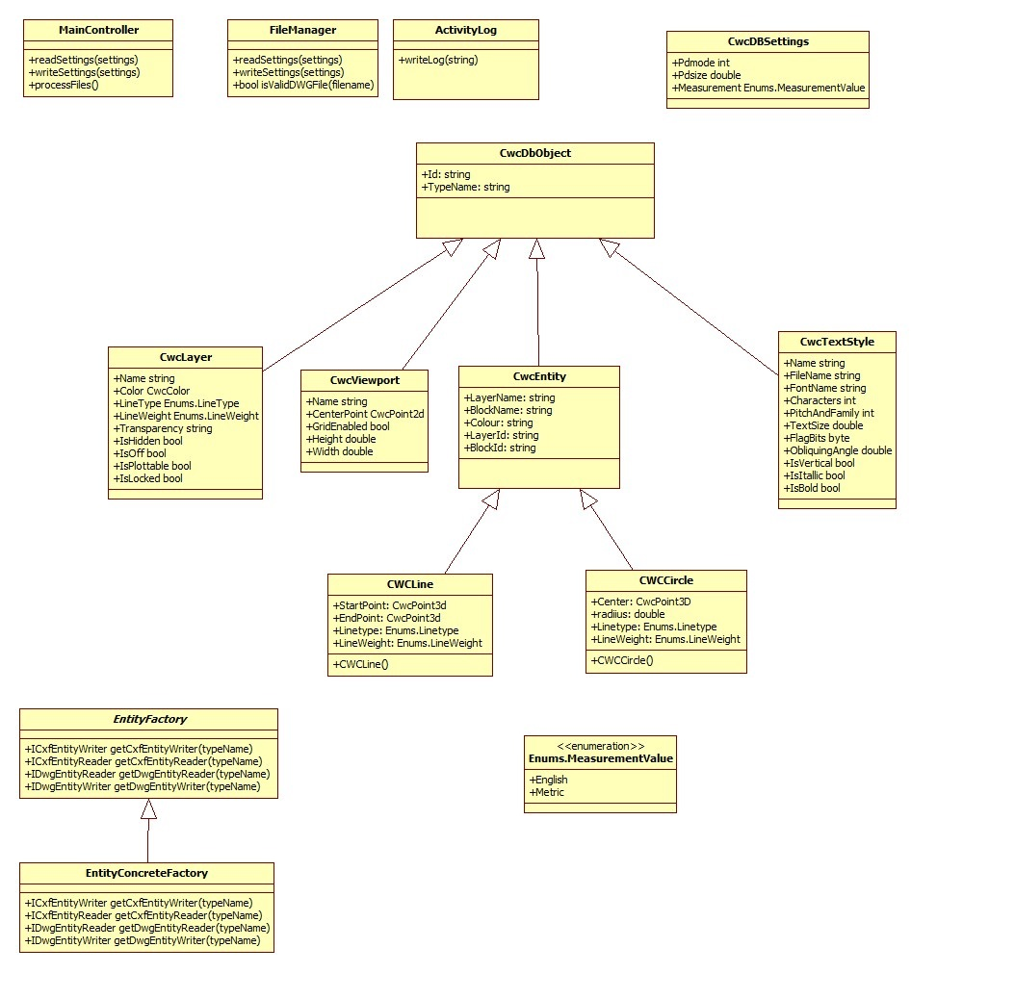
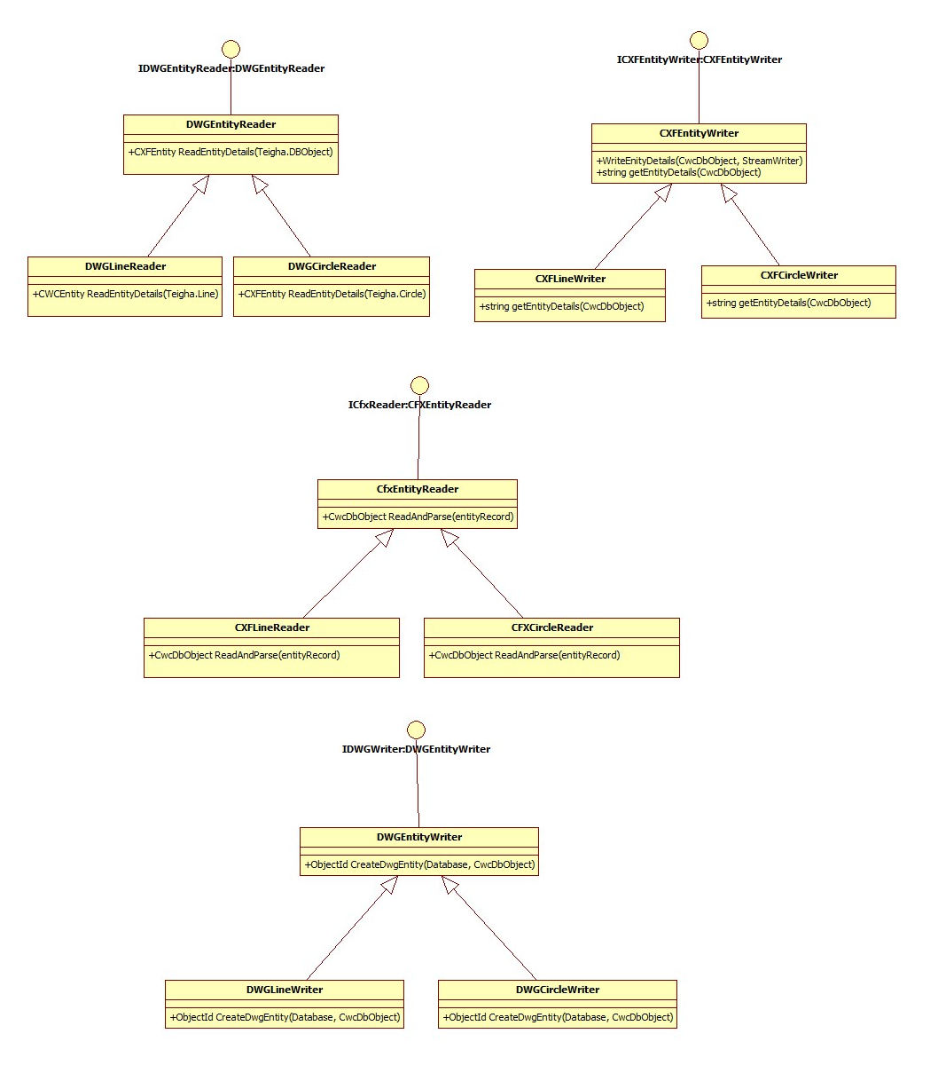

Database Design

ER Model

Not Applicable

Database Object Definitions

Not Applicable

Appendices

https://www.opendesign.com/
Client documents
- CXF format sample
- Process Flow Document
Basic Objects & Properties
COMMON Properties
- Layer No – Layer in which the object is created.
- Line Type–(0=ByLayer, 1=block, 2=layer, 3=center, 4=continuous, 5=dashdot,
6=dashed, 7=dot)
- Line width
- Thickness
ANALYZE
- Value
PAPER
- Size
LAYER
- Layer No
LINE Object
- Sx, Sy –Start X and Y position
- Ex, Ey – End X and Y
CIRCLE Object
- Cx – Center X position
- Cy - Center Y position
- R – Radius
ARC Object
- Cx – Center X position
- Cy - Center Y position
- R - Radius
- Sx, Sy –Start X and Y position
- Ex, Ey – End X and Y
DIMENSIONS Object
- Sx, Sy –Start X and Y position
- Ex, Ey – End X and Y position
- aSx, aSy – angle Start X and Y position
- aEx,aEy – angle End X and Y position
CHARACTER Object
- FONT – Type, Name, Size, Weight etc.
- String – Character Text
- Width – Width of a Character
- Height –Height of a Character
- Cx – Center X position
- Cy - Center Y position
- Pitch – Distance between each Character
COLOR Object
- R G B – Color Value
- x1, y1.. xN,yN – Color x and y Position
ELIPS Object
- Cx – Center X position
- Cy - Center Y position
- R – Radius
CXF Output Format Sample
ANALYZE:
100
PAPER:
A4
LAYER:
1
CIRCLE:
r = 4.08
Cx = 20.86
Cy = 8.17
ELIPSE:
r = 4.08
Cx = 26.67
Cy = 6.4

